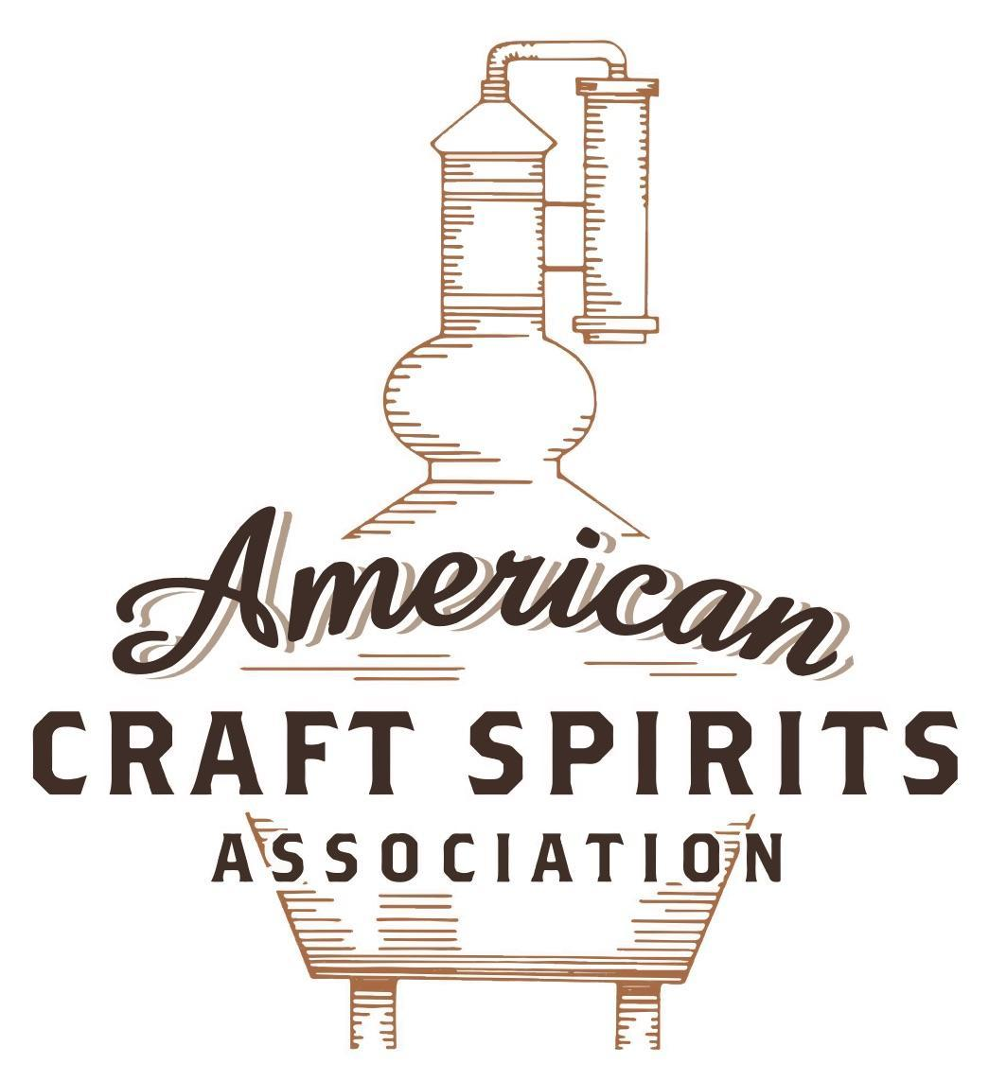
Spirits DtC Shipping Guide

This guide summarizes the direct-to-consumer shipping rules for distilleries in all 50 states and D.C. and also addresses the measures state governments have taken to ease delivery and shipping restrictions during the COVID-19 pandemic.

DtC Quick Guide Comparison

Out-of-State Distilleries  Can Ship Into State? |  |  |  | In-State Distilleries  Can Ship Within State?
State | Yes | No |  | State | Yes | No
AL |  | X |  | AL |  | X
AK | X |  |  | AK | X
AZ | X |  |  | AZ | X
AR |  | X |  | AR |  | X
CA |  | X* |  | CA |  | X*
CO |  | X |  | CO |  | X
CT |  | X* |  | CT |  | X
DE |  | X |  | DE |  | X
DC | X |  |  | DC | X
FL |  | X |  | FL |  | X
GA |  | X |  | GA |  | X
HI |  | X* |  | HI |  | ?*
ID |  | X |  | ID |  | X
IL |  | X* |  | IL |  | X*
IN |  | X |  | IN |  | X
IA |  | X* |  | IA |  | X*
KS |  | X |  | KS |  | X
KY | X |  |  | KY | X
LA |  | X |  | LA |  | X
ME |  | X* |  | ME |  | X*
MD |  | X |  | MD |  | X
MA |  | X |  | MA |  | X
MI |  | X |  | MI |  | X
MN |  | X |  | MN |  | X
MS |  | X |  | MS |  | X
MO |  | X |  | MO |  | X
MT |  | X |  | MT |  | X
NE | X |  |  | NE | X
NV |  | X* |  | NV |  | X
NH | X |  |  | NH |  | X*
NJ |  | X* |  | NJ |  | X*
NM |  | X |  | NM |  | X
NY |  | X* |  | NY |  | X*
NC |  | X |  | NC |  | X
ND | X |  |  | ND | X
OH |  | X |  | OH |  | X
OK |  | X |  | OK |  | X
OR |  | X |  | OR | X
PA |  | X* |  | PA |  | X
RI |  | X* |  | RI |  | X
SC |  | X |  | SC |  | X
SD |  | X |  | SD |  | X
TN |  | X |  | TN |  | X
TX |  | X |  | TX |  | X
UT |  | X |  | UT |  | X
VT |  | X |  | VT |  | X
VA |  | X |  | VA |  | X
WA |  | X* |  | WA | X
WV |  | X* |  | WV |  | X*

WI |  | X |  | WI |  | X
WY |  | X |  | WY |  | X

Notes:
*CA: If passed and signed into law, Senate Bill 620 would allow licensed distilled spirits producers in states other than California and licensed distilled spirits manufacturers or craft distillers in California who obtain distilled spirits direct shipper permits to ship directly to consumers in California
*CT: Consumers with appropriate permit may receive alcohol shipments
*HI: Consumers with appropriate permit may receive alcohol shipments; If passed and signed into law, Senate Bill 65 would allow licensed distilled spirits manufacturers in Hawaii and in states other than Hawaii who obtain direct shipper permits to ship directly to consumers in Hawaii
*IL: If passed and signed into law, Senate Bill 0532 would allow licensed distilled spirits producers in Illinois and in states other than Illinois who obtain distillery shippers’ licenses to ship directly to consumers in Illinois
*IA: If passed and signed into law, House File 639 would allow native distilled spirits manufacturers in Iowa and in states other than Iowa who obtain direct shipper permits to ship directly to consumers in Iowa and to consumers in states other than Iowa
*ME: If passed and signed into law, Legislative Document 1358 would allow distilleries outside of Maine with current manufacturer licenses and distilleries licensed in Maine who obtain spirits direct shipper licenses to ship directly to consumers in Maine
*NJ: (1) If passed and signed into law, Assembly Bill 3167 would allow a craft distillery licensees to ship no more than 9 liters of distilled spirits to a consumer in New Jersey; (2) If passed and signed into law, Senate Bill 3020 would allow craft distillery licensees in New Jersey or in states other than New Jersey to ship no more than 20 liters of distilled spirits to a consumer in New Jersey via common carrier
*NV: Licensed individuals can import one gallon per month of spirits for personal use and the out-of-state supplier must pay excise tax
*NH: If passed and signed into law, Senate Bill 125 would allow licensed liquor manufacturers who obtain direct to consumer shipping permits from the commission to ship directly to consumers in New Hampshire
*NY: Consumer may import up to 90L of liquor per year for personal use without a license; If passed and signed into law, Assembly Bill 3275 would allow licensed liquor manufacturers in states other than New York and licensed distillers and farm distillers in New York to ship no more than thirty-six cases (no more than nine liters per case) of liquor to consumers in New York
*PA: Consumer may place a special liquor order and distiller must ship to a PLCB-operated store
*RI: Distiller can only ship to customer if order was personally placed by customer at distiller's premises
*WA: If passed and signed into law, House Bill 1432 would allow licensed spirits manufacturers in states other than Washington to ship spirits to consumers in Washington
*WV: Distilleries, mini-distilleries, or micro-distilleries licensed in West Virginia or a state other than West Virginia who obtain private direct shipper licenses to ship to a consumer in West Virginia, however the shipments must be made to a retail liquor outlet

HAWAII
Note: This summary looks at Hawaii state law and does not address the specific laws implemented by the liquor commissions of Hawaii, Maui, Honolulu, and Kauai counties. Distillers should look to their local liquor commissions for additional guidance.
Shipment Outbound – Silent.
Shipment Inbound – No, however, an individual may obtain a permit for single shipment for personal consumption. No more than 1 permit may be in respect of any 1 household in any calendar year. The total of liquor shipped cannot exceed 5 gallons or 3.2 gallons if it is a gift (HRS § 281-33.1).
Shipment Intra-state – A manufacturer can sell to any person for private use or consumption a product it manufacturers from fruits or other products grown in HI on its premises. Although the statute says the sale must occur on the premises, the law does not specify whether such product could then be shipped to the purchaser’s home (HRS § 281-31).
COVID-19 Measures – On June 7, 2021, the Hawaii governor signed a Twenty-First proclamation related to the COVID-19 emergency allowing county liquor commissions to continue: 1) allowing licensees to sell unopened beer, wine, or prepackaged cocktails with food for pick-up, delivery, take out, or other means to be consumed off premises; and 2) waive, suspend, or postpone any deadlines or administrative procedures. Distillers must look to their local liquor commissions for additional guidance and relief measures available to them. The current proclamation is valid through August 6, 2021, unless terminated or superseded by a separate proclamation.
Link: https://governor.hawaii.gov/wp-content/uploads/2021/06/2106080-ATG_21st-Emergency-Proclamation-for-COVID-19-distribution-signed.pdf
Citation (shipment)
Hawaii Revised Statutes
§ 281-31 Licenses, classes.
(a) Licenses may be granted by the liquor commission as provided in this section.
(b) Class 1. Manufacturer license. A license for the manufacture of liquor shall authorize the licensee to:
(1) Manufacture the liquor therein specified;
(2) Sell it in original packages to any wholesaler who holds a license to resell it; and
(3) Sell beer, wine, or other specified liquor manufactured or distilled on the licensee's premises from fruits or other products grown in the State, in any quantity:
(A) At wholesale in original packages to any person who holds a license to resell it; and
(B) To any person for private use and consumption. Under this license, no liquor shall be consumed on the premises, except as authorized by the commission. Of this class, there shall be the following kinds:
(1) Beer;
(2) Wine;
(3) Alcohol; and
(4) Other specified liquor.
It shall be unlawful for any holder of a manufacturer license to have any interest whatsoever in the license or licensed premises of any other licensee. This subsection shall not prevent the holder of a manufacturer license under this chapter or under the law of another jurisdiction from maintaining any interest in the license or licensed premises of a wholesale dealer licensee under this chapter.
Link: https://www.capitol.hawaii.gov/hrscurrent/vol05_Ch0261-0319/HRS0281/HRS_0281-0031.htm
§ 281-33.1 Individual permits to receive shipments of liquor.
(a) Notwithstanding any other provisions of law, any unlicensed adult person may apply to the liquor commission and be issued, for a nominal fee, except as hereinafter provided, a permit to receive a single shipment of liquor from outside the State, not to exceed five gallons, (19 liters), for use and consumption by the applicant and the applicant's household and not for sale in any form.
(b) In the case of a shipment that the applicant shows is an unsolicited gift, the quantities permitted to be received under subsection (a) shall be limited to 3.2 gallons (12 liters) in total of all kinds of liquor.
(c) In the case of a shipment in respect of which the applicant shows to the liquor commission that the liquor was prior to the date of the application the personal property of the applicant, formed a part of the applicant's household goods, was used and stored outside the State, and was originally acquired (or made by the applicant) outside the State, the quantity of wine, or other liquor capable of aging and originating from grapes or other fruit, which shall be permitted to be received under subsection (a) may exceed the limit there stated if the commission finds that it is reasonable to do so consistent with the intent of this statute to allow persons taking up residency in the State the free movement of their household goods into this State.
(d) In the case of a shipment of wine or beer that is otherwise available in the State, the permit shall not be issued unless the applicant pays a fee equal to the tax that would be imposed by section 244D-4 upon the use of liquor having a wholesale price equal to the price paid or to be paid by the applicant for the wine or beer being shipped, and such fee shall be in lieu of the imposition by section 244D-4 of any tax upon the use of the wine or beer.
(e) Except in the case of applications meeting the requirements of subsection (b), (c), or (d), the permit shall not be issued unless the applicant demonstrates to the satisfaction of the liquor commission that each of the brands to be brought in under the permit is otherwise unavailable in the State.
(f) No more than one permit may be issued pursuant to subsection (a) in respect of any one household in any calendar year, and each applicant shall be required to affirm, under penalty of perjury, that no member of the applicant's household has previously received such a permit in the applicable calendar year.
(g) All such applications and shipments shall be in accordance with regulations promulgated by the liquor commission.
(h) A common carrier to whom the permit is presented is authorized to make delivery of the described shipment to the person named in the permit. Delivery of such a shipment pursuant to the permit shall not be deemed to constitute a sale in this State.
(i) An unlicensed adult shall not be required to obtain a permit under this section to receive shipments of liquor pursuant to section 281-33.6.
Link: https://www.capitol.hawaii.gov/hrscurrent/Vol05_Ch0261-0319/HRS0281/HRS_0281-0033_0001.htm

The American Craft Spirits Association (ACSA) is working diligently to give our members and industry partners relevant, current updates on statutes and regulations impacting production, sale and distribution of spirits. With the declaration of the novel coronavirus (COVID-19) in early 2020, many states have issued temporary policy changes or longer-term modernization of alcohol beverage laws. State statutes, regulations created by the state alcohol regulatory authority, as well as any other relevant guidance provided by such authorities (such as advisories, opinions, bulletins, etc.) were reviewed in creation of this document. No city or county ordinances were reviewed. Distillers should be aware that even in states where direct shipping is permissible, always remember to avoid shipping to dry counties. Please consult with your state guild or alcohol beverage authority for the most up-to-date information. This content is intended for educational and informational purposes only. ACSA's pro bono law firm of Malkin Law P.A. provided the core content found in this comprehensive overview of the spirits distribution after COVID-19. It was completed in August 2021 and will be updated regularly. If you have updates you would like to provide, please send to legislation@americancraftspirits.org or directly to the law firm at: ryan@malkin.law / malkin.law. Thank you.
S.B. 65, introduced on January 1, 2021, would allow a distilled spirits manufacturer with a license issued by another state to obtain a direct shipper permit to directly ship distilled spirits to a consumer at least 21 years of age in any county for personal use. The bill was crossed over on February 22, 2021 and is in committee. Link: https://www.capitol.hawaii.gov/session2021/bills/SB65_HD1_.HTM
S.B. 65, introduced on January 1, 2021, would allow a licensed distilled spirits manufacturer to obtain a direct shipper permit to directly ship distilled spirits to a consumer at least 21 years of age in any county for personal use. The bill was crossed over on February 22, 2021 and is in committee. Link: https://www.capitol.hawaii.gov/session2021/bills/SB65_HD1_.HTM

